DAY 1 LIST OF EXPERIMENTS

EXPERIMENT NO:01

Aim:

To compute the median of the given data using R programming .

Code:

# Provided data

intervals <- c("1-5", "5-15", "15-20", "20-50", "50-80", "80-110")

frequencies <- c(200, 450, 300, 1500, 700, 44)

# Calculate cumulative frequencies

cumulative_frequencies <- cumsum(frequencies)

# Identify the median class

median_class_index <- which(cumulative_frequencies >= sum(frequencies) / 2)[1]

median_class <- intervals[median_class_index]

# Extract lower and upper bounds of the median class

lower_bound <- as.numeric(strsplit(median_class, "-")[[1]][1])

upper_bound <- as.numeric(strsplit(median_class, "-")[[1]][2])

# Compute the median

N <- sum(frequencies)

CF <- cumulative_frequencies[median_class_index - 1]

f <- frequencies[median_class_index]

w <- upper_bound - lower_bound

median_value <- lower_bound + ((N/2 - CF) / f)

cat("Median Value: ", median_value, "\n")

OUTPUT:

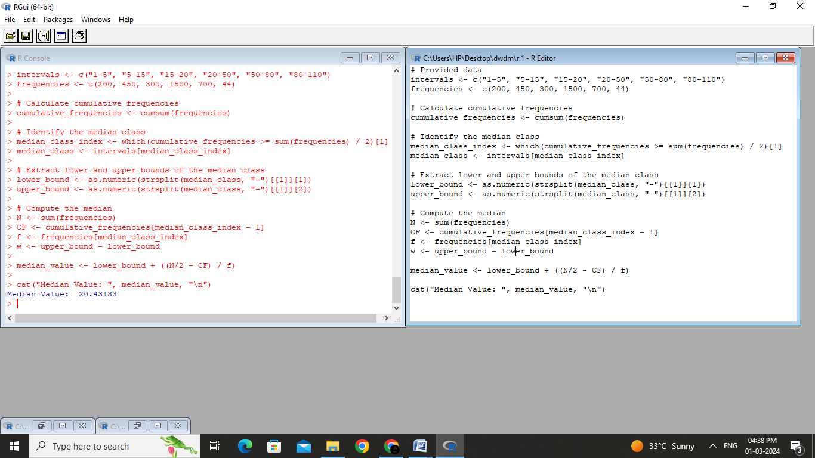

Result:

The median is calculated successfully for the given data using the R programming.

EXPERIMENT NO :02

Aim:

To compute the median , mode , mean, midrange and quartiles(1,3) of the attribute age.

Code

# Data

age_data <- c(13, 15, 16, 16, 19, 20, 20, 21, 22, 22, 25, 25, 25, 25, 30, 33, 33, 35, 35, 35, 35, 36, 40, 45, 46, 52, 70)

# (a) Mean and Median

mean_age <- mean(age_data)

median_age <- median(age_data)

cat("Mean: ", mean_age, "\n")

cat("Median: ", median_age, "\n\n")

# (b) Mode and Modality

# Note: Mode may not exist or there can be multiple modes

mode_result <- table(age_data)

modes <- as.numeric(names(mode_result[mode_result == max(mode_result)]))

cat("Mode(s): ", ifelse(length(modes) > 1, paste(modes, collapse = ", "), "None"), "\n")

#cat("Modality: ", ifelse(length(modes) > 1, paste("Multimodal (", length(modes), " modes)", sep = ""), "Unimodal"), "\n\n")

# (c) Midrange

midrange <- (min(age_data) + max(age_data)) / 2

cat("Midrange: ", midrange, "\n\n")

# (d) Quartiles

q1 <- quantile(age_data, 0.25)

q3 <- quantile(age_data, 0.75)

cat("First Quartile (Q1): ", q1, "\n")

cat("Third Quartile (Q3): ", q3, "\n")

Output:

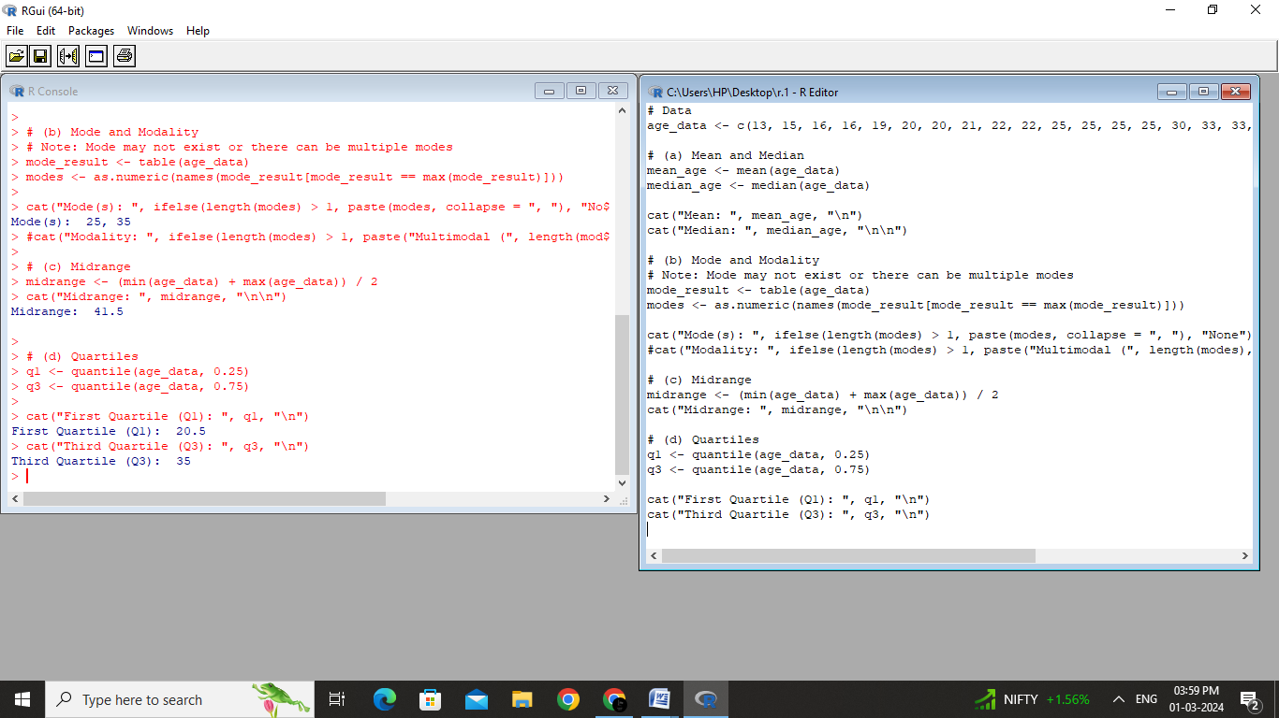

Result:

The mean , median , mode and midrange , quartiles of the given data are successfully calculated using R programming

EXPERIMENT NO:03

Aim:

To normalize the given data using the min max algorithm and z-score algorithm using R programming.

Code:

# Data

data <- c(200, 300, 400, 600, 1000)

# (a) Min-Max Normalization

min_max_normalized <- (data - min(data)) / (max(data) - min(data))

cat("(a) Min-Max Normalization:\n")

cat("Original Data: ", data, "\n")

cat("Min-Max Normalized Data: ", min_max_normalized, "\n\n")

# (b) Z-Score Normalization

z_score_normalized <- (data - mean(data)) / sd(data)

cat("(b) Z-Score Normalization:\n")

cat("Original Data: ", data, "\n")

cat("Z-Score Normalized Data: ", z_score_normalized, "\n")

Output:

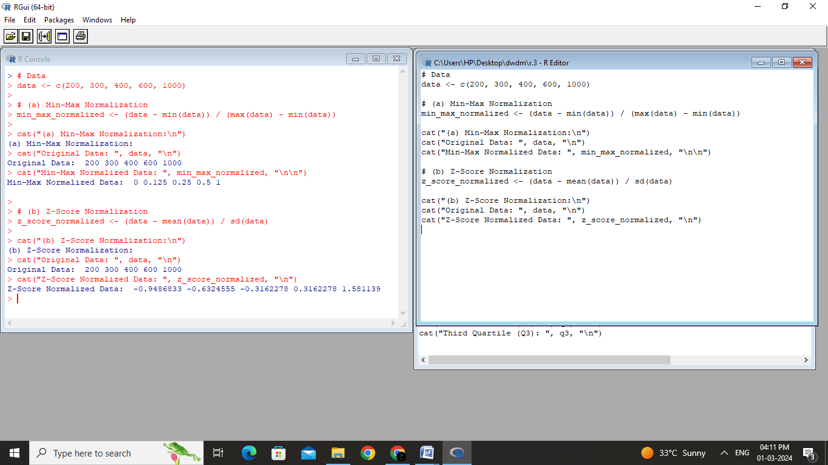

Result:

The given data is normalised using the min max algorithm and z-score algorithm by constructing executing R programming code.